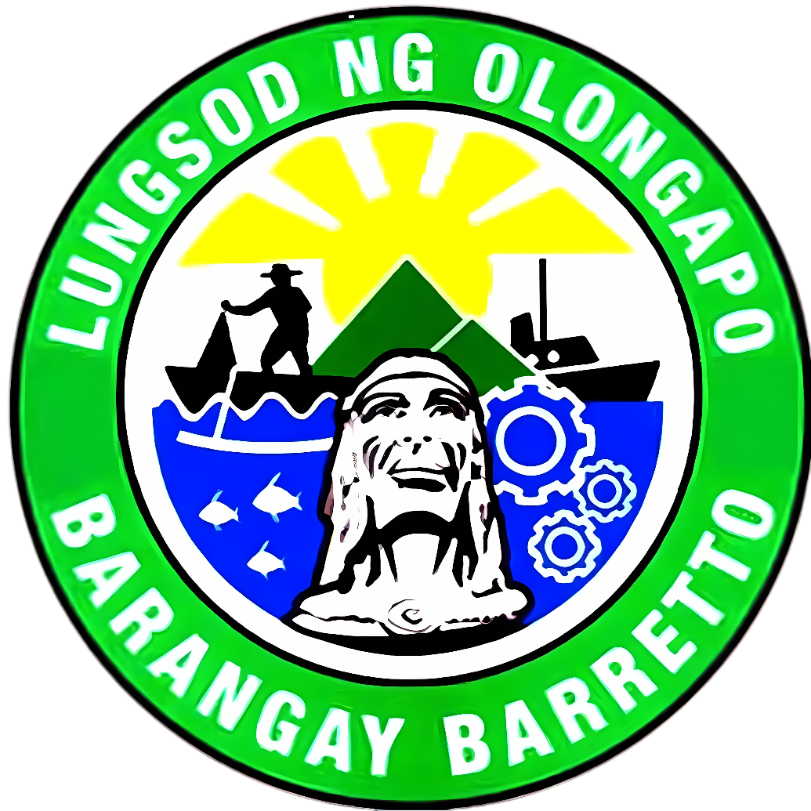
BARANGAY OFFICIALS 2025 – 2026
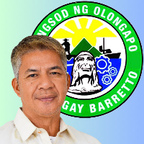
HON. DANTE U. ESCOBAR Punong Barangay
Hon. Ronald M. Elayda Kagawad Committee on Sanitation and Environmental Protection Committee on Fishers and Agriculture
Hon. Jan Guiseppe M. Abarro Kagawad Committee on Health Committee on Livelihood and Cooperativies
Hon. Rolan A. Napuli Kagawad Committee on Labor and Employment Committee on Education and Culture
Hon. Wilfredo G. Avila Kagawad Committee on Security and Public Order
Hon. Bethasaida G. Albarda Kagawad Committee on Social Services, Woman and Family Committee on Laws and Rules Committee on Budget and Apropriation and Ways and Means Committee on Business, Trade and Industry
Hon. Lydia D. Demorse Kagawad Committee on Tourism Beautification, Parks and Plaza
Hon. Herbert S. Doles Kagawad Committee on Public Works and Engineering Committee on Transportation and Communication Committee on Land Matters
Hon. Angeli Raiza P. Bonilla SK Chairwoman Committee on Youth and Sports Development
Mr. Jester Dan M. Banda Barangay Secretary
Mrs. Rosemarie E. Medenilla Barangay Treasurer
Mr. Darwin G. Dancel Barangay Administrator

BARANGAY CLEARANCE
TO WHOM IT MAY CONCERN:
This is to certify that the person whose name, picture and signature appear hereon has requested a BARANGAY CLEARANCE from this office and the result are listed below.
NAME
{fullName}
ADDRESS
{address}
DATE AND PLACE OF BIRTH
{birthDate} – {placeOfBirth}
PURPOSE
{purpose}
REMARKS

APPLICANT SIGNATURE

VERIFIED BY: APPROVED BY:

DATE ISSUED: {dateRequested} VALID UNTIL: {validUntil}
JONALYN A. BUYAG LUPON CLERK
HON. DANTE U. ESCOBAR Punong Barangay
“Barangay Ko, Kasama Ako Sa Pag-Unlad Nito.”

